ADVANCED SOFTWARE ENGINEERING
(ASSIGNMENT-2)
Sudheer Kumar Raganaboina
Student ID: 16162638

In this assignment work, I have used the concepts of Javascript, CSS and HTML.
All these three together are used in the Jsfiddle.
In these assignment, we got familiar using the google map services API, weather Services API.
(i) Initially, in the first step I have signed up into JSFIDDLE by the user name "sudheer589"
(ii)In the next step, I selected a google service API from the Google APP services
(iii) I tried to design an application where the user enters the starting and destination address. Then the respective route need to be displayed to the user.
(iv) Later on I have used a code for HTML,CSS and JAVASCRIPT in their respective fields.
(v) In JSFIDDLE I have selected a jQuery 2.0.2 and in that I have selected jQuery Mobile 1.3.1 from Framework and Extensions field.
(vi) I used the google map API Services for writing the code for JavaScript.
(vii) A “control” function is used in the jquery and I have used :
$('#submit').click(function()
{
calcRoute();
}

(viii)After writing the complete code for the application I have selected the RUN method in JSFIDDLE.
(ix) In the final step, I got my application running successfully and it is displaying the desired directions
successfully.

JSFIDDLE LINK: http://jsfiddle.net/sudheer589/5v2XR/1/

HTML CODE:
<script src="https://maps.googleapis.com/maps/api/js?v=3.exp&sensor=false"></script>
<body>
<div id="control">
<input type="text" placeholder="Starting Location" name="start" id="start" value=""/>
<input type="text" placeholder="Ending Location" name="end" id="end" value=""/>

<select id="mode">
<option value="DRIVING">Driving</option>
<option value="WALKING">Walking</option>
<option value="BICYCLING">Bicycling</option>
<option value="TRANSIT">Transit</option>
</select>
<input type="submit" id="submit" value="submit"/>

</div>
<div id="map-canvas" style="width:500px;height:500px"></div>

JAVASCRIPT CODE:
$('#control').ready(function()
{
initialize(36.588056, -116.943056);
$('#submit').click(function()
{
calcRoute();

});
});
var directionsDisplay;
var directionsService = new google.maps.DirectionsService();
var map;
function initialize(lat,lan) {
directionsDisplay = new google.maps.DirectionsRenderer();
var mapOptions = {
zoom: 7,
mapTypeId: google.maps.MapTypeId.ROADMAP,
center:new google.maps.LatLng(lat,lan)
}
map = new google.maps.Map(document.getElementById('map-canvas'), mapOptions);
directionsDisplay.setMap(map);
var control = document.getElementById('control');
control.style.display = 'block';
map.controls[google.maps.ControlPosition.TOP_CENTER].push(control);
}

function calcRoute() {
var selectedMode = document.getElementById('mode').value;
var a = document.getElementById('start').value;
var b = document.getElementById('end').value;
var request = {
origin: a,
destination: b,

travelMode: google.maps.TravelMode[selectedMode]
};
directionsService.route(request, function(response, status) {
if (status == google.maps.DirectionsStatus.OK) {
directionsDisplay.setDirections(response);
}
});
}

CSS CODE:
body {
height: 100%;
margin: 0;
padding: 0;
}

SCREEN SHOTS:

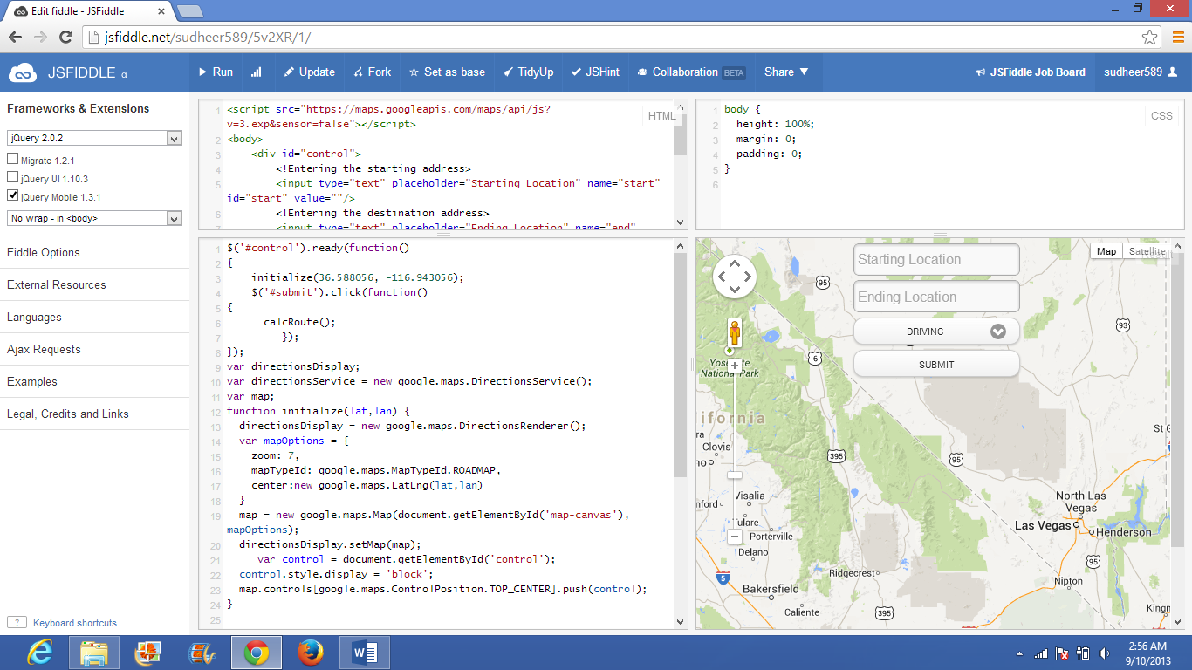

JSFIDDLE page after execution of the code.

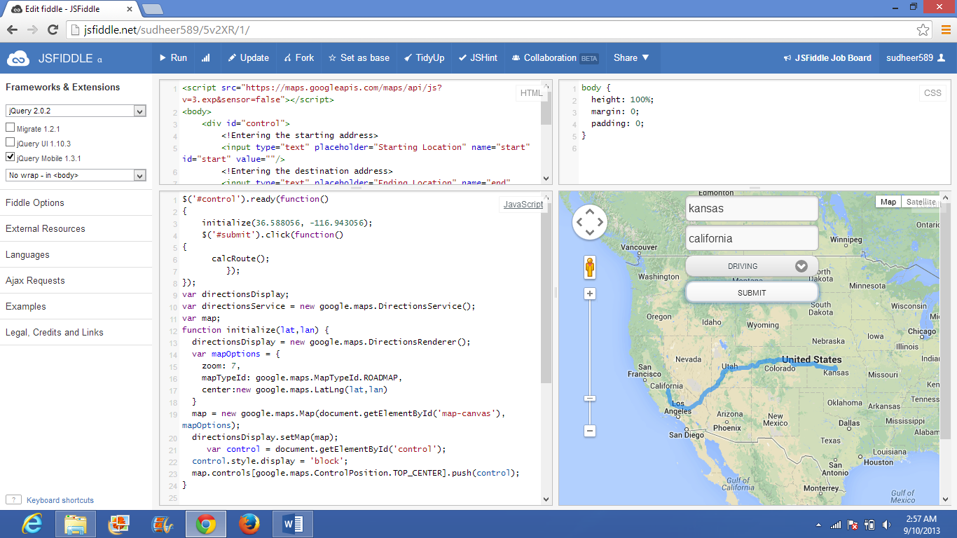
Desired starting location and destination locations are entered as the inputs. And after clicking the submit button the desired route map is displayed.

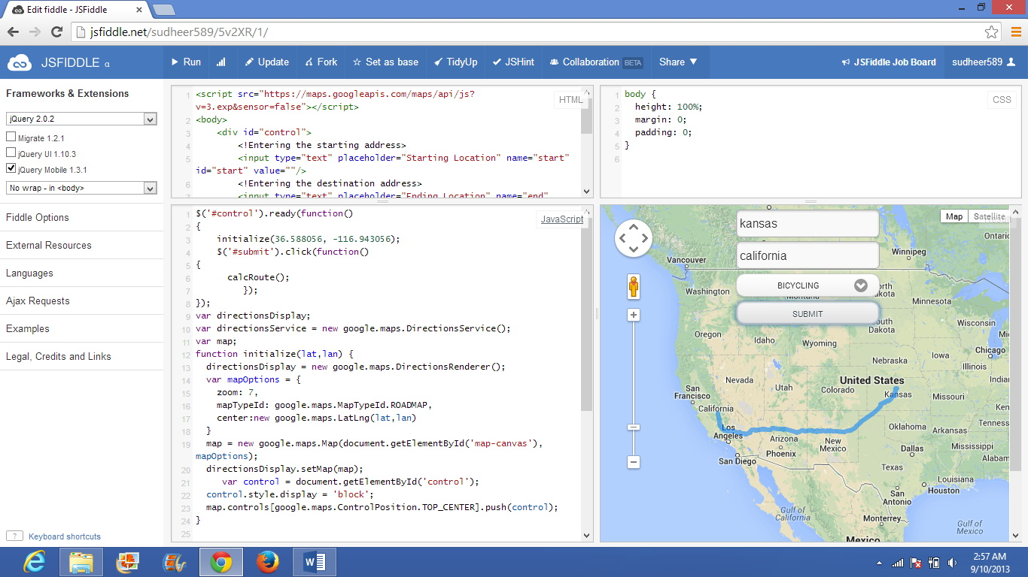
The mode of travel is changed to bicycling then the route map for that mode is displayed.

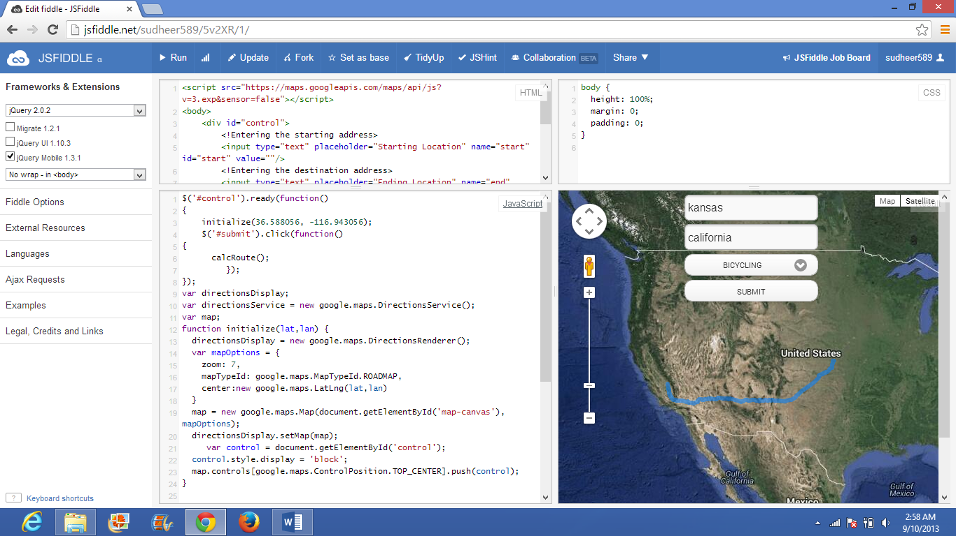
The satellite view of the route map can be obtained from the application.

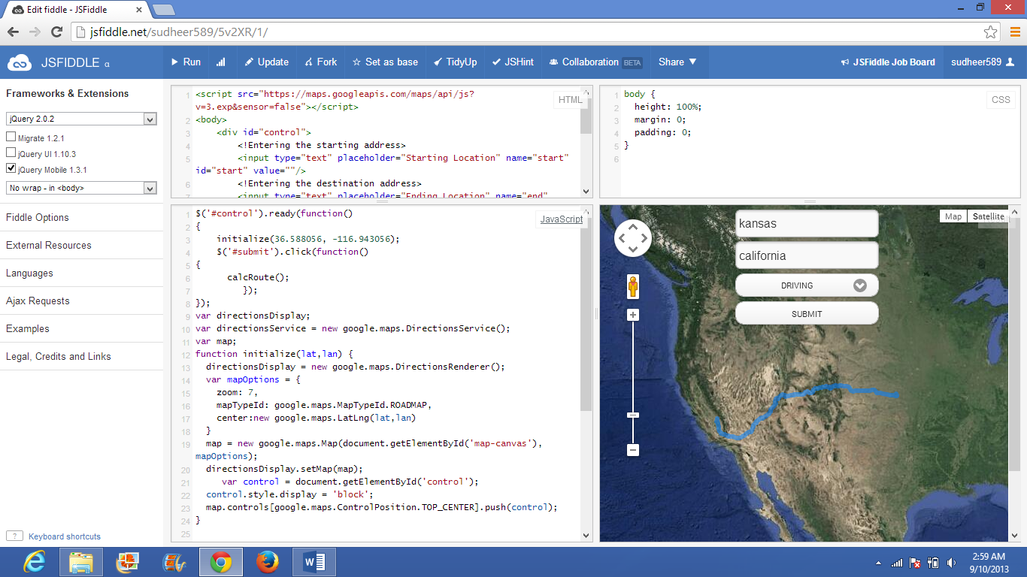

Satellite view of the locations in the driving mode.

Thus successfully the application is designed according to the requirements.

THANK YOU

